Test Plan - Team Gold Squadron

Testing Process Evaluation Stages:

1. Thermometer (Reading correct temperature)
2. Verify established connection between third box and computer
3. Verify correct temperatures are transmitted to computer from third box to computer
4. Connection established between computer and phone
5. Verify correct temperature/data is transferred from computer to phone
6. Waterproof check
7. Drop test
8. Threshold test (Temperature too hot or too cold)

Project Description:

1. Brief Description:

Our team is to design a system that incorporates a waterproof thermometer with a easy-to-use web interface that displays the readings of temperature over time. This temperature can be displayed in Fahrenheit or Celsius formats. The system also utilizes a notification system where the user may define maximum and minimum temperature thresholds, once reached, will send a warning with a custom message to a cellular device, by which the user designates the phone number. This is also includes a subsystem that connects to thermometer. This subsystem is to be structurally sound and visually display the temperature via a minimum of seven LED lights in binary format. This subsystem will only operate with an on switch and a button press on the device by a user.

1. Schematic:

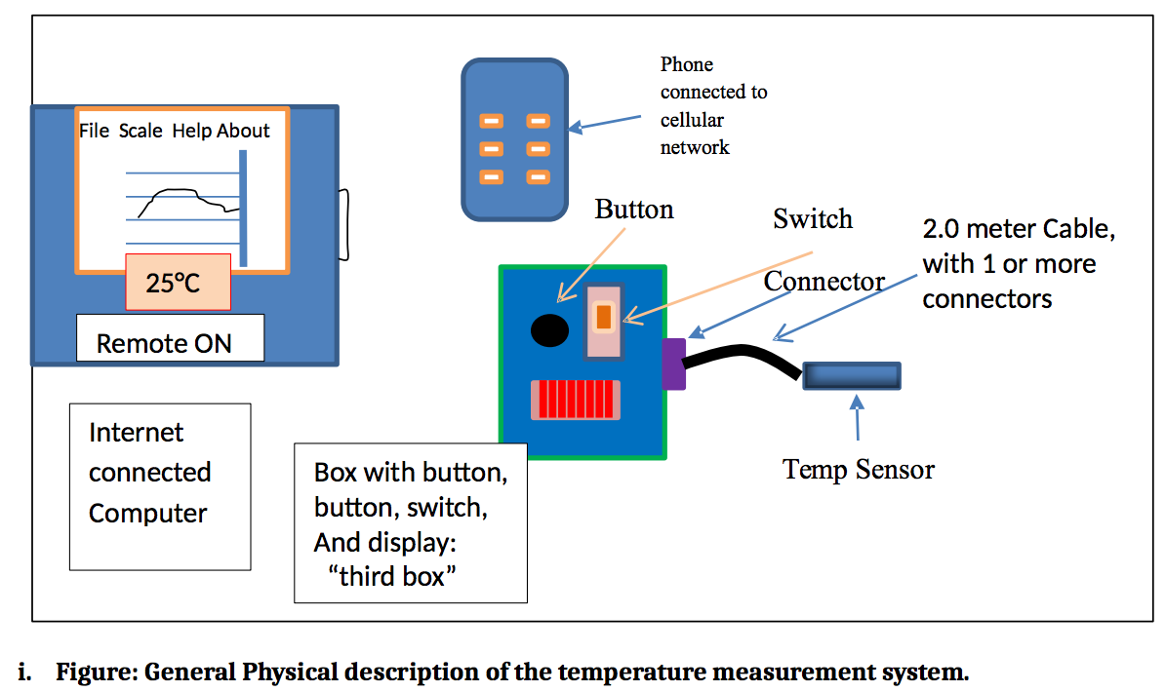

(Schematic provided by the Lab 1 Project Assignment)

1. Base requirements:

The four main components to our design system:

* A computer (of any operating system) that is connected to the internet.
  + This is used to display the user interface and control the system settings.
* A thermometer sensor that must be waterproof and a minimum of 2 meters long.
* A subsystem or “third box” that is the hardware indication of the working system.
* A cellular device that can receive text messages via a designated phone number.

Thermometer Testing:

1. Compare to stand alone thermometer:

In order to test the accuracy of our thermometer, we plan to equip a standard market thermometer and compare the measurements from the two devices on several different occasions and testing subjects. If the standalone market thermometer is within a reasonably small variation with our system’s thermometer measurement, we can be confident in our system's accuracy.

**Test Results: PASS** To test, we hooked up the thermometer to our arduino and compared it to a standard mercury thermometer while putting them in different degrees of water.

1. Ice cold temperature comparison:

Another sound solution besides comparing our design to another measurement device, is to compare it to actual physics. We plan to plan to place our thermometer in water that contains mostly ice. That way we may assume that the temperature of the water is roughly zero degrees celsius. If our measurement is close to zero or 32 degrees fahrenheit then we may conclude that our measurement for the cooler temperature spectrum are accurate.

**Test Results: PASS** To test, we hooked up the thermometer to our arduino and compared its reading to a standard mercury thermometer while in a cup of ice water and the values between the two thermometers were very similar.

1. Boiling water comparison:

Along with the ice water system test, we may do a similar experiment with boiling water. We know that boiling water is roughly 100 degrees celsius. We compare measurements in the same way and conclude our results.

**Test Results: PASS** To test, we hooked up the thermometer to our arduino and compared it to a standard mercury thermometer in a hot water cup and the values between the two thermometers were very similar.

1. Room temperature comparison:

Our last experiment will be the simplest, as it is the standalone temperature that we view when the thermometer is unaffected in any way. This measurement will most likely be roughly 18-26 degrees celsius.

**Test Results: PASS** To test, we hooked up the thermometer to our arduino and compared its room temperature reading to a standard mercury thermometer and the values between the two thermometers were very similar.

Verify Connection between computer and third box:

1. Compare temperatures in user interface on computer:

This is a simple experiment test as we just need to verify that we are in fact getting an accurate temperature from our hardware device. This process is being tested to verify that our wired connections are working properly. We should be able to attach and detach our cable system to the third box and have the readings disappear and reappear. If these tests our a success, then we may conclude that we will have no issues attaching our system to other computers of similar software architecture.

**Test Results: PASS** To test, we had our system running and recording temperature values and then removed the temperature cable. Upon doing this, the graph stopped graphing. When we plugged it back in, the graph continued plotting the temperature points without any other user interaction.

Connection established between computer and phone:

1. When thermometer is too hot send message to phone:

Simply put, there is only one way to verify if the connection from the computer to phone is working properly, and that is if the phone we have designated in our settings, has received a text message with our desired message format. For this case however, we are testing that when our thermometer reads a temperature that is above the upper threshold that we have designated, then the system will attempt to send a text message to the phone detailing that “The Thermometer has reached a temperature of __ degrees C, which has exceeded the maximum system limit of __ degrees C”. If the phone receives this message, then we may conclude that our system is working properly.

**Test Results: PASS** To test, we ran our system with the temperature sensor reading room temperature. We then changed the max temperature threshold while running to simulate the temperature getting too hot. Upon doing this, the system sent a text message to the phone that stated the temp was over the max, and then also told them the current temperature that set off the warning.

1. When thermometer is too cold send message to phone:

This test is almost exactly the same as the previous test, the only difference is the message content. The desired message should be in the format “The Thermometer has dropped below the temperature of __ degrees C, which has exceeded the minimum system limit of __ degrees C”. If the phone receives this message, then we may conclude that our system is working properly.

**Test Results: PASS** To test, we ran our system with the temperature sensor reading room temperature. We then changed the min temperature threshold while running to simulate the temperature getting too cold. Upon doing this, the system sent a text message to the phone that stated the temp was under the min, and then also told them the current temperature that set off the warning.

Physical Requirements of Third Box:

1. Drop test:

This set of tests is to conclude that our third box system is structurally sound. As in, the system will not break or fail to operate if the hard is dropped from a height that is equivalent to our laboratory desks. We conduct this experiment by simply dropping the system from that specified height, after we believe we have fortified our system thoroughly enough to conduct this test. If this test fails, we must repair any damages to the system and reevaluate our safety design and then finally test again. If it succeeds, the our design may be considered durable to design specifications.

**Test Results: PASS** To test, we placed all parts of the design securely in the box. We then dropped it from table height. After we dropped it, we checked inside the box to make sure no parts had come undone, and then plugged it back into the computer to make sure the program would still run.

1. Water test:

This test will be evaluating the integrity of our thermometer. Our measurement device is required to waterproof up to its 2 meters in length. We have acquired our desired measurement tool but must extend the length to the 2 meter designation. This will require stripping and then attaching the remaining length, and insuring that the connection is waterproof. We insure our design is in working condition by submerging it in water and attempting to receive a signal from the thermometer. If we receive an accurate reading, then we may conclude that our measurement device is up to design specifications.

**Test Results: PASS** To test, the 2.1 meter thermometer was submerged in water to make sure it wouldn’t short while running.